Chapter 12, Solution 71.

- If 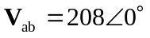, 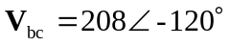, 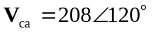,
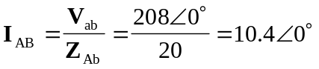
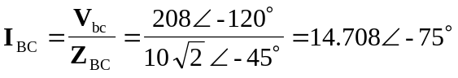
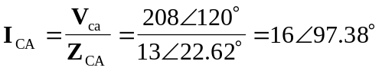

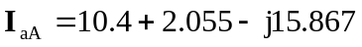
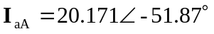

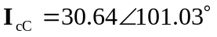

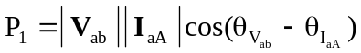
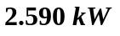

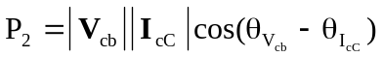
But 

 